Assignment 7 Solutions

1.
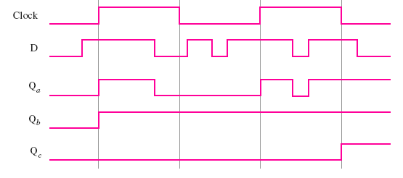

2.
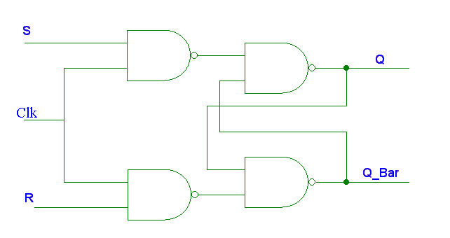

3.
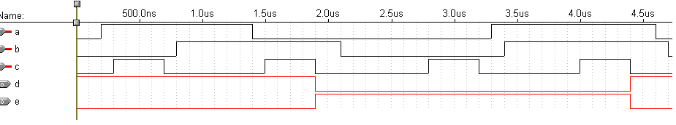
4.
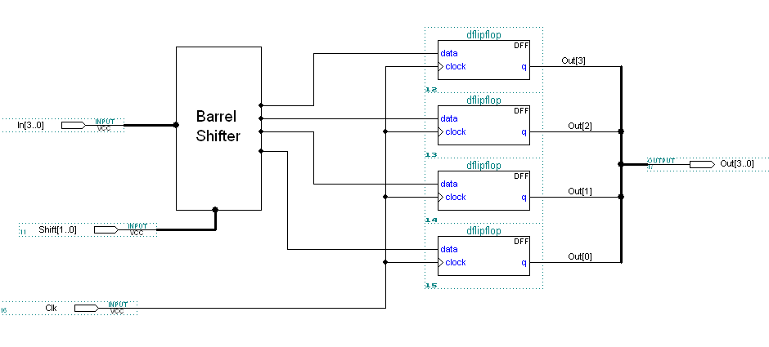
5. a) Period_{F} = n*t_{p}

b) After the interval is over, the number stored in the flip-flop will be the total number of cycles for 100ns. So Period_{F} will be equal to 100ns divided by value of the flip-flop.
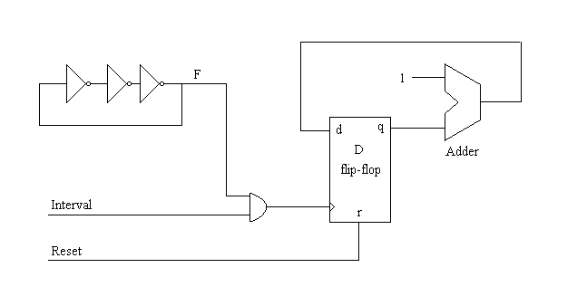

6.
