Assignment 12 Solutions

First derive state excitation table:
Present State | Flip-flop Inputs
Present State | w = 0 |  |  | w = 1 |  |  | Output
y2y1 | Y2Y1 | J2K2 | J1K1 | Y2Y1 | J2K2 | J1K1 | z
00 | 10 | 1d | 0d | 11 | 1d | 1d | 0
01 | 01 | 0d | d0 | 00 | 0d | d1 | 0
10 | 11 | d0 | 1d | 00 | d1 | 0d | 0
11 | 10 | d0 | d1 | 01 | d1 | d0 | 1

Get Expressions for J2, K2, J1, K1, and Z:
J2 = y1’
K2 = w
J1 = K1 = w XOR y2
Z = y2.y1

Draw circuit:
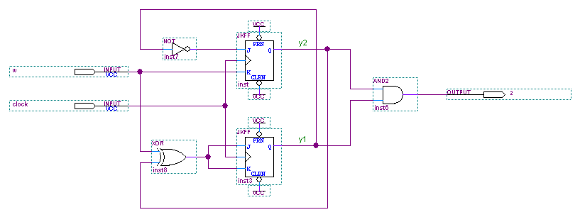

- a) Moore Machine:

Initial
0
“1”
0
“10”
0
“11”
0
“110”
1
“101”
1
1
1
1
1
1
1
0
0
0
0
0
0

Name | Present State | Next State |  | Output
Name | Present State | input =1 | input=0 | Output
Name | y2y1y0 | Y2Y1Y0 | Y2Y1Y0 | Z
Initial | 000 | 001 | 000 | 0
"1" | 001 | 010 | 101 | 0
"11" | 010 | 010 | 110 | 0
"110" | 011 | 100 | 000 | 1
"101" | 100 | 010 | 101 | 1
"10" | 101 | 100 | 000 | 0

Equations:
Y2 = (y2 + y1).(w’y0’+wy0)+w’y2’y1’y0
Y1 = wy2y0’+y1y0’+ wy2’y1’y0
Y0 = w’y2y0’ + wy2’y1’y0’ + w’y2’y1’y0
Output = y1y0 + y2y0’
Circuit:
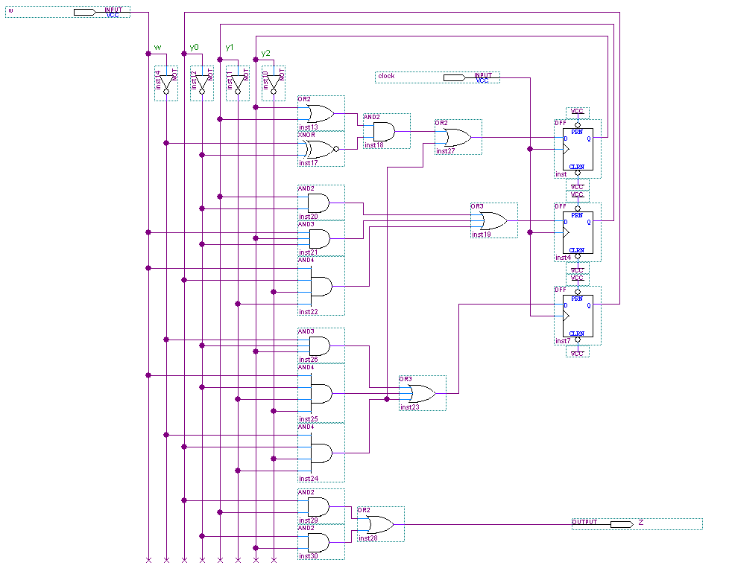
b) Mealy Machine:

Initial

“1”

“10”

“11”

“110”

“101”
0 / 0
0 / 0
1 / 0
1 / 0
1 / 0
0 / 0
0 / 1
1 / 1
1 / 0
1 / 1
0 / 0
Name | Present State | Next State |  | Ouput
Name | Present State | input=0 | input =1 | input=0 | input =1
Name | y2y1y0 | Y2Y1Y0 | Y2Y1Y0 | Z | Z
Initial | 000 | 000 | 001 | 0 | 0
"1" | 001 | 101 | 010 | 0 | 0
"11" | 010 | 110 | 010 | 1 | 0
"110" | 011 | 000 | 100 | 0 | 1
"101" | 100 | 101 | 010 | 0 | 0
"10" | 101 | 000 | 100 | 0 | 1

Equations:
Y2 = (y2 + y1).(w’.y0’+w.y0)+w’.y2’.y1’.y0
Y1 = w.y2.y0’+y1.y0’+ w.y2’.y1’.y0
Y0 = w’.y2.y0’ + w.y2’.y1’.y0’ + w’.y2’.y1’.y0
Output = w’.y0’.y1 + w.y0.(y2+y1)

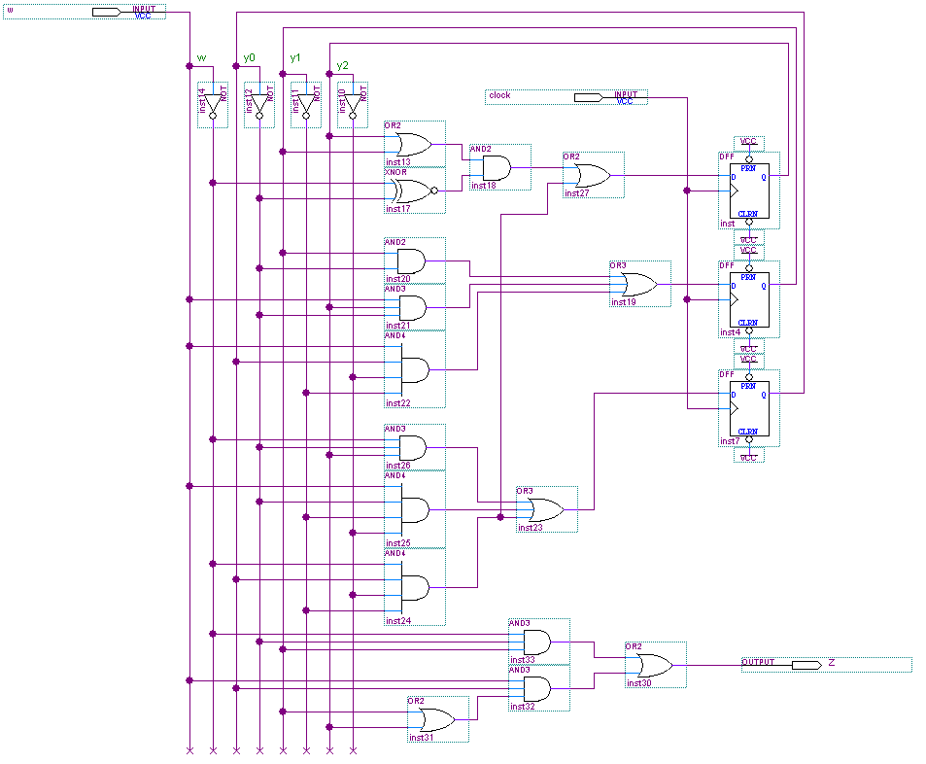

11, 00
0 equal
0
01, 10
1 equal
0
Input is given as {w1w2}
2 equal
0
4 equal
1
3 equal
0
11, 00
11, 00
11, 00
01, 10
01, 10
01, 10
01, 10
11, 00

Name | Present State | Next State, (input = w1w2) |  |  |  | Ouput
Name | Present State | 00 | 01 | 10 | 11 | Ouput
Name | y2y1y0 | Y2Y1Y0 | Y2Y1Y0 | Y2Y1Y0 | Y2Y1Y0 | Z
0 equal | 000 | 001 | 000 | 000 | 001 | 0
1 equal | 001 | 010 | 000 | 000 | 010 | 0
2 equal | 010 | 011 | 000 | 000 | 011 | 0
3 equal | 011 | 100 | 000 | 000 | 100 | 0
4 equal | 100 | 100 | 000 | 000 | 100 | 1

Equations:
Define W, s.t. W=1 when w2=w1 else W=0.

Y2 = W.(y2+y1.y0)
Y1 = W.(y1.y0’+y1’.y0)
Y0 = W.y2’.y0’

Circuit:
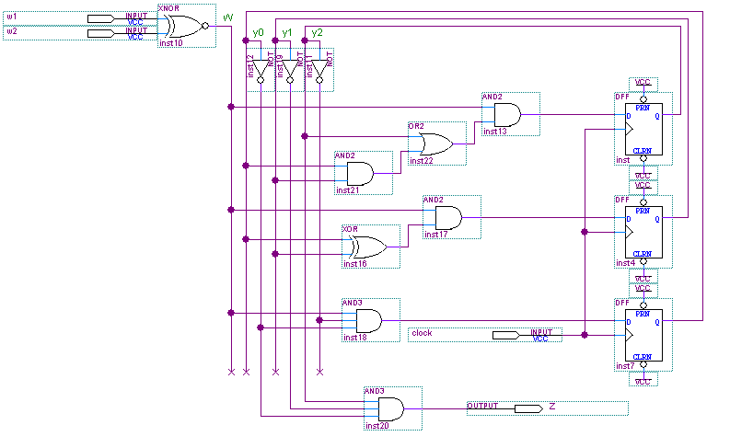

- Verilog Code:
module prob4(clock, reset, out, w1, w2);

input clock, reset, w1, w2;
output out;

//define state registers
reg [2:0] current, new;

//define allowable states
parameter [2:0] ZERO = 3'b000, ONE = 3'b001, TWO = 3'b010, THREE = 3'b011, FOUR = 3'b100;

always @(w1 or w2 or current)
begin
if (w1 == w2)
case (current)
ZERO: new = ONE;
ONE: new = TWO;
TWO: new = THREE;
THREE: new = FOUR;
FOUR: new = FOUR;
default: new = 3'bxxx;
endcase
else
new = ZERO;
end

always @(negedge reset or posedge clock)
if (reset == 0)
current = ZERO;
else
current = new;

assign out = (current == FOUR);

endmodule

Waveform:
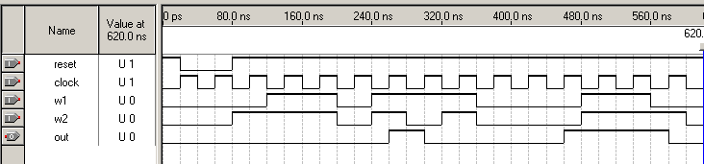

Present State | Flip-flop Inputs
Present State | w = 0 |  |  |  | w = 1
y2y1y0 | Y2Y1Y0 | J2K2 | J1K1 | J0K0 | Y2Y1Y0 | J2K2 | J1K1 | J0K0
000 | 111 | 1d | 1d | 1d | 010 | 0d | 1d | 0d
001 | 000 | 0d | 0d | d1 | 011 | 0d | 1d | d0
010 | 001 | 0d | d1 | 1d | 100 | 1d | d1 | 0d
011 | 010 | 0d | d0 | d1 | 101 | 1d | d1 | d0
100 | 011 | d1 | 1d | 1d | 110 | d0 | 1d | 0d
101 | 100 | d0 | 0d | d1 | 111 | d0 | 1d | d0
110 | 101 | d0 | d1 | 1d | 000 | d1 | d1 | 0d
111 | 110 | d0 | d0 | d1 | 001 | d1 | d1 | d0

Equations:
J2 = K2 = w’.y0’.y1’ + w.y1
J1 = K1 = w + y0’
J0 = w’.y0’
K0 = w’.y0

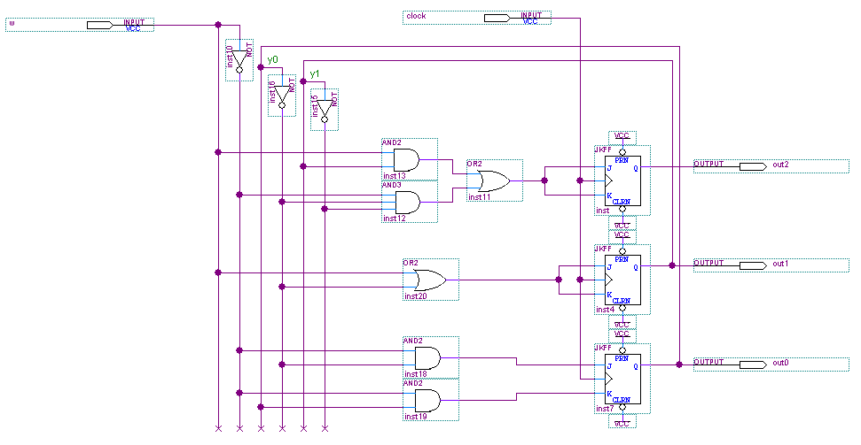
Circuit:

