Assignment 3 Solutions

- a)
X | S | Y | F
0 | 0 | 0 | 0
0 | 0 | 1 | 0
0 | 1 | 0 | 0
0 | 1 | 1 | 1
1 | 0 | 0 | 1
1 | 0 | 1 | 1
1 | 1 | 0 | 0
1 | 1 | 1 | 1
b) F = XS' + YS
- a)
a | b | c | a+b | (a+b).a' | c.b | (a+b).a'+c.b | (a'+c) | (a'+c).b
0 | 0 | 0 | 0 | 0 | 0 | 0 | 1 | 0
0 | 0 | 1 | 0 | 0 | 0 | 0 | 1 | 0
0 | 1 | 0 | 1 | 1 | 0 | 1 | 1 | 1
0 | 1 | 1 | 1 | 1 | 1 | 1 | 1 | 1
1 | 0 | 0 | 1 | 0 | 0 | 0 | 0 | 0
1 | 0 | 1 | 1 | 0 | 0 | 0 | 1 | 0
1 | 1 | 0 | 1 | 0 | 0 | 0 | 0 | 0
1 | 1 | 1 | 1 | 0 | 1 | 1 | 1 | 1

b) (a+b).a' + c.b => a.a' +b.a' + c.b (Distributive)
=> b.a' + c.b (Complementarity)
=> b.(a' + c) (Distributive)
c) (a+b).a' + c.b = (a’+c).b becomes (a.b+a’).(c+b) = (a’.c)+b (dual theorem)
(a’.c)+b => (a’+b).(c+b) (Distributive)
=> (a.b+a’).(c+b) (Absorption alternate form)

3. a)
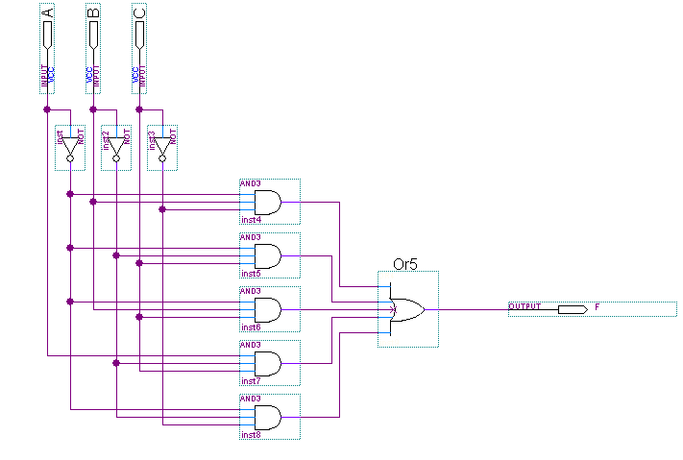
b) 9 gates + 23 total inputs = 32
c) f(a, b, c) = a’ + ab’c
d)
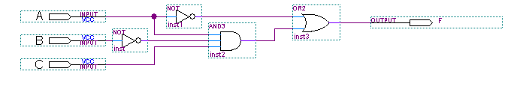
e) 4 gates + 7 inputs = 11

- a)
a | b | c | d | f |  | a | b | c | d | f
0 | 0 | 0 | 0 | 1 |  | 1 | 0 | 0 | 0 | 0
0 | 0 | 0 | 1 | 0 |  | 1 | 0 | 0 | 1 | 1
0 | 0 | 1 | 0 | 0 |  | 1 | 0 | 1 | 0 | 1
0 | 0 | 1 | 1 | 1 |  | 1 | 0 | 1 | 1 | 0
0 | 1 | 0 | 0 | 0 |  | 1 | 1 | 0 | 0 | 1
0 | 1 | 0 | 1 | 1 |  | 1 | 1 | 0 | 1 | 0
0 | 1 | 1 | 0 | 1 |  | 1 | 1 | 1 | 0 | 0
0 | 1 | 1 | 1 | 0 |  | 1 | 1 | 1 | 1 | 1
b) f (a, b, c, d) = a'b'c'd’ +a'b'cd + a'bc'd + a'bcd’ + ab'c'd + ab'cd’ + abc'd’ + abcd
c) f (a, b, c, d) = Σ m(0, 3, 5, 6, 9, 10, 12, 15)
d) f (a, b, c, d) = (a+b+c+d’).(a+b+c'+d).(a+b'+c+d).(a+b'+c'+d’).(a'+b+c+d). (a'+b+c'+d’).(a'+b'+c+d’).(a'+b'+c'+d)
e) f (a, b, c, d) = Π M(1, 2, 4, 7, 8, 11, 13, 14)
f) f' (a, b, c, d) = Σ m(1, 2, 4, 7, 8, 11, 13, 14)
g) f' (a, b, c, d) = Π M(0, 3, 5, 6, 9, 10, 12, 15)

- a) From a truth table: f(a, b, c) = a'b'c' + a'b'c + a'bc' + ab'c' + ab'c + abc' + abc
b) f(a, b, c) = a + b' + c' (after simplified with Boolean algebra)
c) f(a, b, c) = (a + b' + c')

- a)
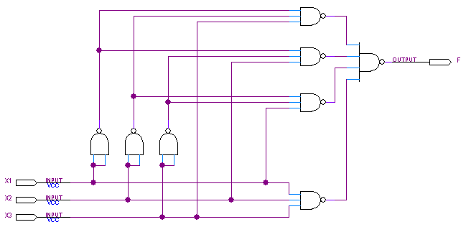
b)
