Assignment 4 Solutions
1. module prob1 (x1, x2, x3, f);
input x1, x2, x3;
output f;

not(nx1, x1);
not(nx2, x2);
not(nx3, x3);
and(w1, x1, x2, x3);
and(w2, x1, nx2, nx3);
and(w3, nx1, x2, nx3);
and(w4, nx1, nx2, x3);
or(f, w1, w2, w3, w4);

endmodule

2. Simplified circuit (using K-map or Boolean algebra): f = x1’.x3+x2.x3’+x1.x2’
module prob2 (x1, x2, x3, f);
input x1, x2, x3;
output f;

not(nx1, x1);
not(nx2, x2);
not(nx3, x3);
and(w1, nx1, x3);
and(w2, x2, nx3);
and(w3, x1, nx2);
or(f, w1, w2, w3);
endmodule

3. module fulladd (a, b, cin, sum, cout);
input a, b, cin;
output sum, cout;

assign sum = a ^ b ^ cin;
assign cout = (a & b) | (a & cin) | (b & cin);

endmodule
OR
module halfadd (a, b, sum, cout); module fulladd(a, b, cin, sum, cout);
input a, b; input a, b, cin;
output sum, cout; output sum, cout;
wire w, c1, c2;
xor(sum, a, b); halfadd ha1 (a, b, w, c1);
and (cout, a, b); halfadd ha2 (w1, cin, sum, c2);
or(cout, c1, c2);

endmodule endmodule
- A) a)
x1 | x2 | x3 | f
0 | 0 | 0 | 0
0 | 0 | 1 | 1
0 | 1 | 0 | 1
0 | 1 | 1 | 0
1 | 0 | 0 | 1
1 | 0 | 1 | 0
1 | 1 | 0 | 0
1 | 1 | 1 | 1

b) We need 3 NOT gates, 4 3-input AND gates, and one 4 input OR gate. It takes 2 transistors per NOT gate, 8 per AND gate, and 10 for the OR gate. Thus, total is
3*2 + 4*8 + 10 = 48 transistors.

B) a) Analyzing the multiplexer circuit, g = x₁.(x₂.x₃ + x₂’.x₃’) + x₁’.(x₂.x₃’ + x₂’.x₃),
Simplifying gives g = x₁.x₂.x₃ + x₁.x₂’.x₃’ + x₁’.x₂.x₃’ + x₁.x₂’.x₃ which is equivalent to the sum of products obtained from P3.1.

b) We need 1 NOT gate and 3 MUXes, at 2 transistors for a NOT gate and 6 per MUX, this gives at total of 2 + 3*6 = 20 transistors (using transmission gates for multiplexer, alternately, using 1 NOT, 2 AND, and 1 OR for MUX => 20/MUX, so 62 total).

- a)
x1 | x2 | x3 | x4 | f
0 | 0 | 0 | 0 | 1
0 | 0 | 0 | 1 | 0
0 | 0 | 1 | 0 | 0
0 | 0 | 1 | 1 | 0
0 | 1 | 0 | 0 | 1
0 | 1 | 0 | 1 | 0
0 | 1 | 1 | 0 | 0
0 | 1 | 1 | 1 | 0
1 | 0 | 0 | 0 | 1
1 | 0 | 0 | 1 | 0
1 | 0 | 1 | 0 | 0
1 | 0 | 1 | 1 | 0
1 | 1 | 0 | 0 | 0
1 | 1 | 0 | 1 | 0
1 | 1 | 1 | 0 | 0
1 | 1 | 1 | 1 | 0

b) f = x1’x3’x4’ + x2’x3’x4’
We would need 4 NOT gates, 2 3-input ANDs, and 1 2-input OR, so
4*2 + 2*8 + 6 = 30 transistors.

- a)
a | b | c | d | f
0 | 0 | 0 | 0 | 1
0 | 0 | 0 | 1 | 0
0 | 0 | 1 | 0 | 0
0 | 0 | 1 | 1 | 1
0 | 1 | 0 | 0 | 0
0 | 1 | 0 | 1 | 1
0 | 1 | 1 | 0 | 1
0 | 1 | 1 | 1 | 0
1 | 0 | 0 | 0 | 0
1 | 0 | 0 | 1 | 1
1 | 0 | 1 | 0 | 1
1 | 0 | 1 | 1 | 0
1 | 1 | 0 | 0 | 1
1 | 1 | 0 | 1 | 0
1 | 1 | 1 | 0 | 0
1 | 1 | 1 | 1 | 1

b + c)
ab
cd | 00 | 01 | 11 | 10
00 | 1 | 0 | 1 | 0
01 | 0 | 1 | 0 | 1
11 | 1 | 0 | 1 | 0
10 | 0 | 1 | 0 | 1

Sum of products
f = a’b’c’d’ + a’b’cd + a’bc’d + a’bcd’ + ab’c’d + ab’cd’ + abc’d’ + abcd.
Product of sums
f = (a+b+c+d’).(a+b+c’+d).(a+b’+c+d).(a+b’+c’+d’).(a’+b+c+d).(a’+b+c’+d’).(a’+b’+c+d’). (a’+b’+c’+d)

d) circuit for (b)

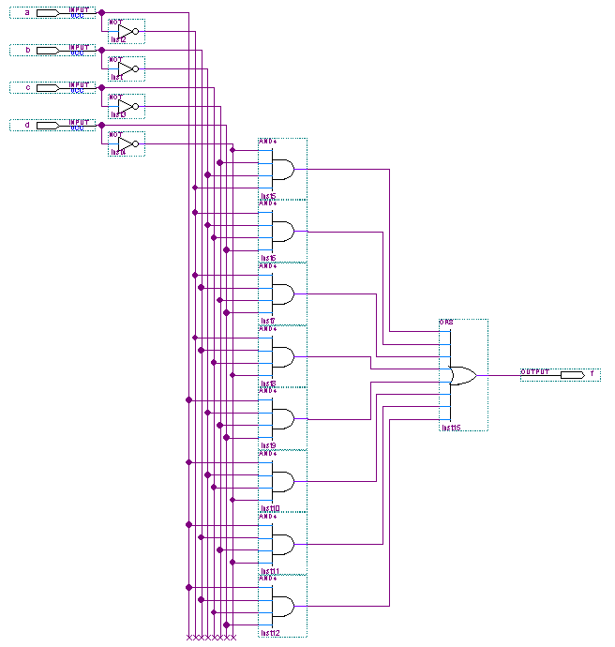

circuit for (c)
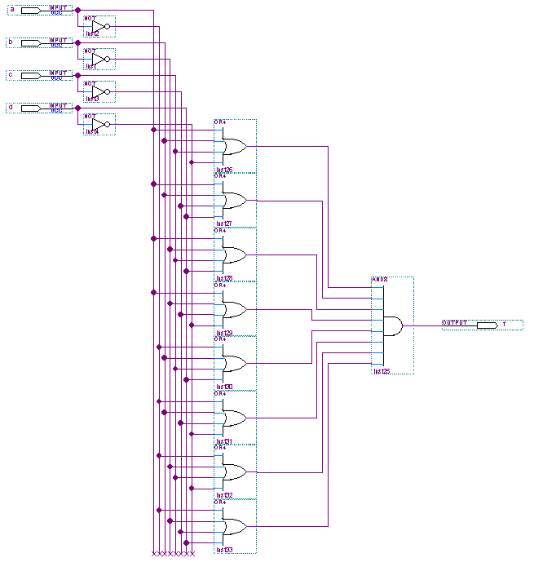
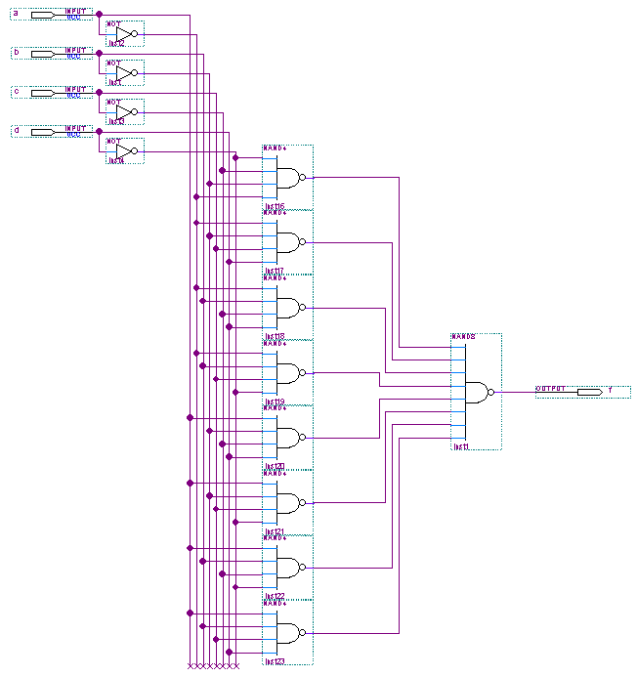
e) circuit for (b)

circuit for (c)
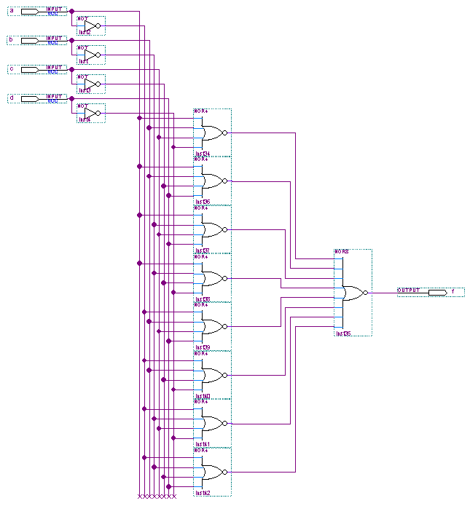

f)
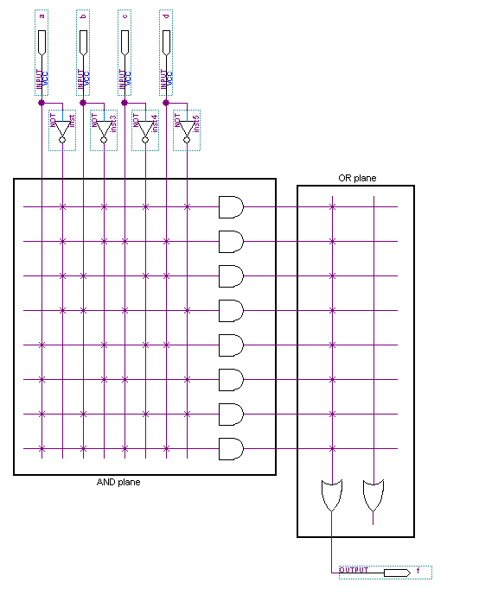

g)

