Assignment 5 Solutions
1. a)

P1 P0 Q1 Q0 | C
0 0 0 0 | 1
0 0 0 1 | 1
0 0 1 0 | 1
0 0 1 1 | 1
0 1 0 0 | 0
0 1 0 1 | 1
0 1 1 0 | 1
0 1 1 1 | 1
1 0 0 0 | 0
1 0 0 1 | 0
1 0 1 0 | 1
1 0 1 1 | 1
1 1 0 0 | 0
1 1 0 1 | 0
1 1 1 0 | 0
1 1 1 1 | 1

b)
P1 P0 Q1 Q0 | 0 0 | 0 1 | 1 1 | 1 0
0 0 | 1 | 1 | 1 | 1
0 1 | 0 | 1 | 1 | 1
1 1 | 0 | 0 | 1 | 0
1 0 | 0 | 0 | 1 | 1

C = P1’.P0’ + Q1.Q0 + P1’.Q0 + P1’.Q1 + P0’.Q1

c)
C = (P1’ + Q1).(P0’ + Q1 + Q0).(P1’ + P0’ + Q0)

d)
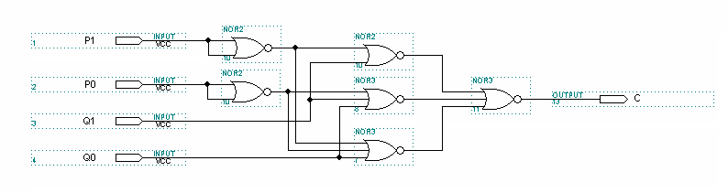

2. a)

A B C D | L
0 0 0 0 | 0
0 0 0 1 | 0
0 0 1 0 | 0
0 0 1 1 | 0
0 1 0 0 | 0
0 1 0 1 | 1
0 1 1 0 | 1
0 1 1 1 | 1
1 0 0 0 | 1
1 0 0 1 | 1
1 0 1 0 | 1
1 0 1 1 | 1
1 1 0 0 | 1
1 1 0 1 | 1
1 1 1 0 | 1
1 1 1 1 | 1

b) L = A + B.(C + D)

c) One possible solution is (there are many):
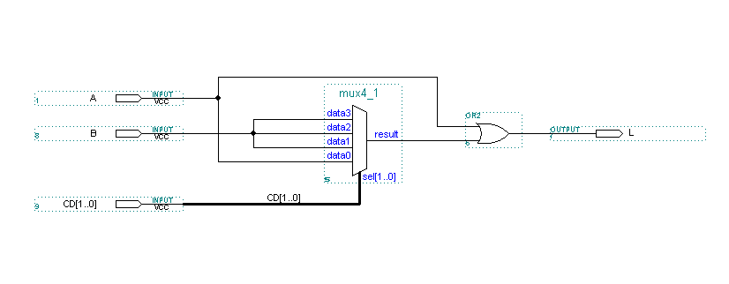

3.
Assuming 0 means doors open, seatbelt unbuckled, or parking brake off.
D S B | I
0 0 0 | 0
0 0 1 | 1
0 1 0 | 0
0 1 1 | 0
1 0 0 | 0
1 0 1 | 0
1 1 0 | 1
1 1 1 | 0

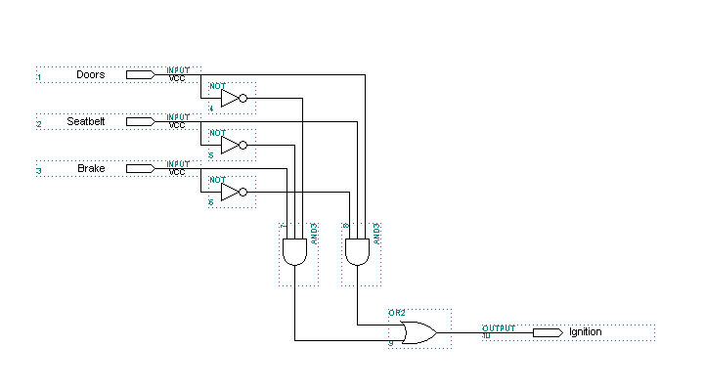
I = D’S’B + DSB’
4.
A B Cin | S | Cout
0 0 0 | 0 | 0
0 0 1 | 1 | 0
0 1 0 | 1 | 0
0 1 1 | 0 | 1
1 0 0 | 1 | 0
1 0 1 | 0 | 1
1 1 0 | 0 | 1
1 1 1 | 1 | 1
a)
g = a and b
p = a xor b (or a or b) either is acceptable since a=1 b=1 is a don’t care condition

b)
Sum = p xor Cin

c) Carry out logic
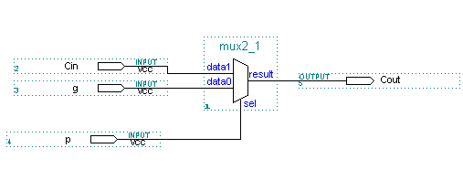

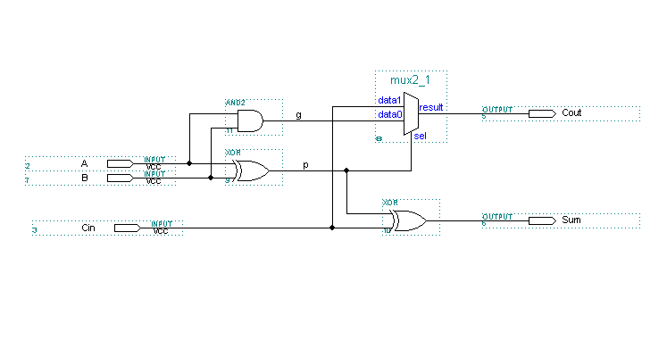
Full 1 bit adder

